**Supplier File FMS to Kofax for eInvoice Validation**

Control M Job : FMSGB_P_NZL_OIC_03AD  
Run Control : KOFAX_ANZ_GEN_EXTR_SUPDATA_D1

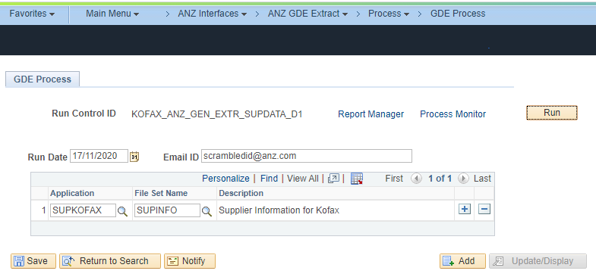

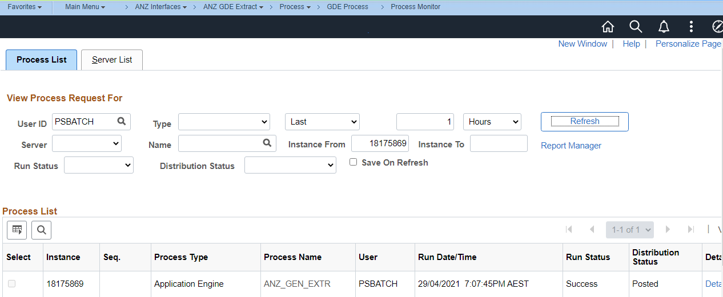

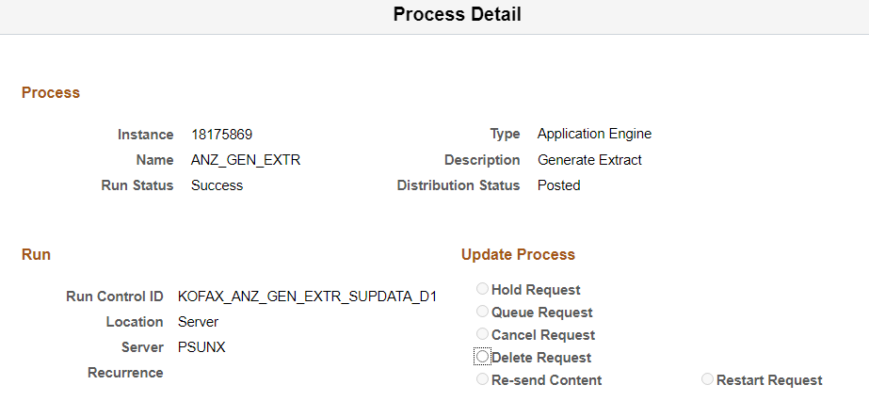

File generated in the below NAS.

